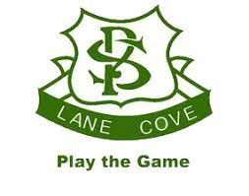

**LCPS P&C General Meeting**

**Term 3 Meeting 1**

**Tuesday 20th July 2021**

**7pm, via Zoom**

**AGENDA**

1. Acknowledgement of Country/General Welcome

1. Adoption of Previous Minutes

1. Principal’s Report

1. Treasurer’s Report

1. Subcommittee Reports
   1. Music
   2. Canteen
   3. Uniform

1. General Business
   1. Covid Impacts
   2. Update on Kindy playground
   3. Update on Hall/Canteen
   4. Planning for events and fundraising in the current environment
   5. LCPS Resource changes

1. Any Other Business